Update – Strike Day 11
(look out for daily updates on each strike day!)
UCU Higher Education Committee (HEC) meeting today to consider UCU/UUK proposals from 6 days of ACAS talks. Strike action continues till we hear back from HEC. LUCU branch meeting on Wednesday to decide LU position on proposals.
The USS strikes have demonstrated an unprecedented level of determination. Many people, taking action for the first time, are fully committed to seeing this through to the end. It is the very future of higher education which is at stake - and we know it.
“In no successful business do smart leaders deliberately alienate frontline workers”. The Financial Times get it…“…vice-chancellors’ salaries outstrip those of leaders of NHS trusts and local authorities” says the Guardian. It’s hard work alienating university staff!
In contrast, Sunday night’s charity gig with Peloton and other acts brought more joy and dancing – a new community is born, and it’s planning on having fun! The gig also brought in £461 to the local hardship fund. And the National Education Union presented us a cheque of another £500 on Monday. We’re touched and invigorated by the solidarity shown to us!
Teach out at the Gregson. 12:30-2:30: The new strike community – FORWARD. How we can maintain the new space opened by the strike, and for what purposes?
-----------------------------------------------------------------------------------------------------------------------------------

Update – Strike Day 11
(look out for daily updates on each strike day!)
UCU Higher Education Committee (HEC) meeting today to consider UCU/UUK proposals from 6 days of ACAS talks. Strike action continues till we hear back from HEC. LUCU branch meeting on Wednesday to decide LU position on proposals.
The USS strikes have demonstrated an unprecedented level of determination. Many people, taking action for the first time, are fully committed to seeing this through to the end. It is the very future of higher education which is at stake - and we know it.
“In no successful business do smart leaders deliberately alienate frontline workers”. The Financial Times get it…“…vice-chancellors’ salaries outstrip those of leaders of NHS trusts and local authorities” says the Guardian. It’s hard work alienating university staff!
In contrast, Sunday night’s charity gig with Peloton and other acts brought more joy and dancing – a new community is born, and it’s planning on having fun! The gig also brought in £461 to the local hardship fund. And the National Education Union presented us a cheque of another £500 on Monday. We’re touched and invigorated by the solidarity shown to us!
Teach out at the Gregson. 12:30-2:30: The new strike community – FORWARD. How we can maintain the new space opened by the strike, and for what purposes?
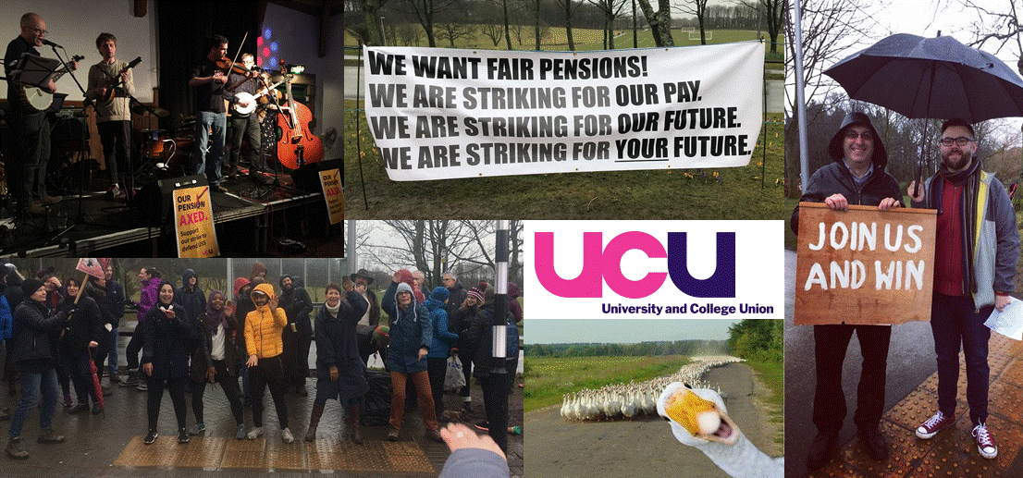
A New Community Is Born
Solidarity Forever
A New Community Is Born
Solidarity Forever

